## My Profile Page – Screenshot

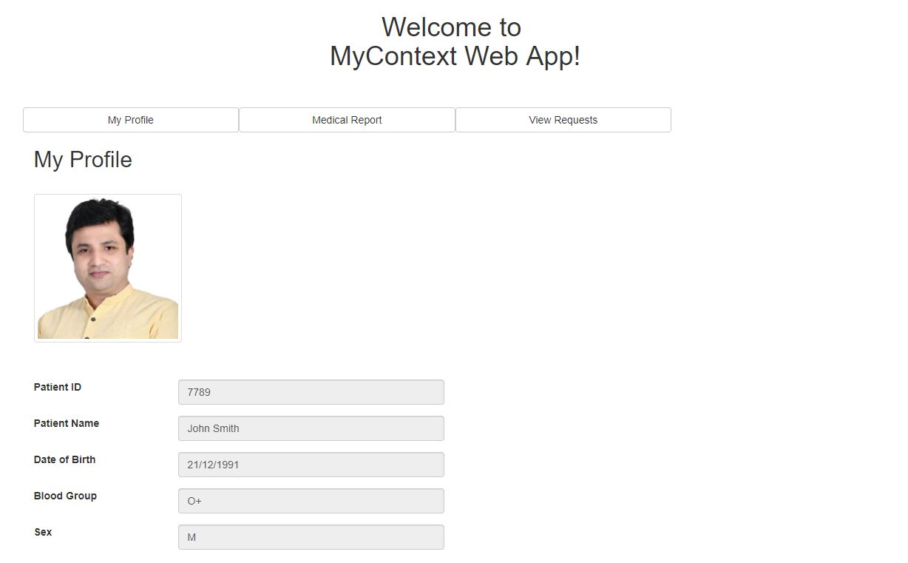

Figure : My Profile Page in Patient Dashboard